TeleFax 039 2051786 Email info@caivillasanta.org

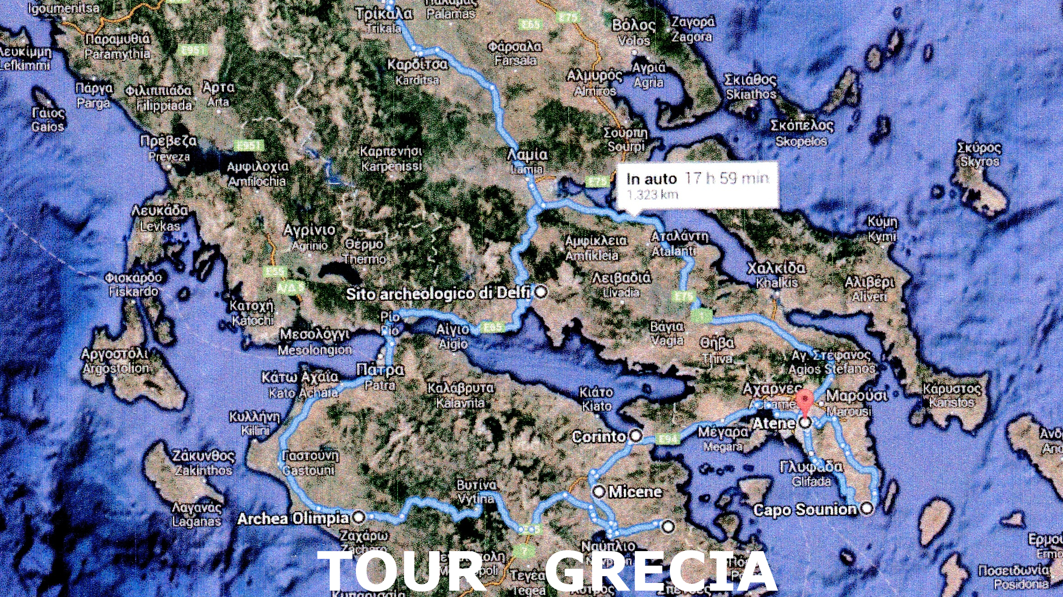

TOUR GRECIA

Tappe e Kilometraggio

Lunedì 16/6/14 Villasanta – Malpensa Bus km. 65 Aereo Malpensa – Atene arrivo previsto per le 14,30

Martedì 17/6/13 Atene visita città e partenza per Cap Sounion Km. 65 + ritorno Atene Km. 130

Mercoledì 18/6/14 Atene – Corinto – Micene –Epidravos – Olimpia odos Km. 78

Giovedì 19/6/14 Olimpia Odos – Delfi Km. 173

Venerdì 20/6/14 Delfi – Kalambaka Km. 227

Sabato 21/6/14 Kalambaka – Monasteri delle Meteore – Atene Km. 350

Domenica 22/6/14 visita città Atene e partenza con aereo per Milano Malpensa più bus per
Villasanta

